**Abstract -** Driver Drowsiness Detection System monitors the driver's eye and mouth using a camera, and by developing an algorithm, the system detects signs of driver’s fatigue. Many tragic accidents can be avoided if drivers are warned in advance. So, this system is helpful in detecting fatigue of driver beforehand and gives warning output as an alarm. The related aspects of drowsiness are retrieved from facial gestures such as eye closure and yawning to determine the drowsiness’s degree. For actualizing this system OpenCV library has been utilized, to avoid street accidents, this library relies on continuous facial image inspection to inform the driver of sleepiness and lack of attention. Images of the driver's face have been taken by a webcam. An algorithm has been proposed to determine the degree of drowsiness by estimating the duration of an eyelid blink and yawning so that the driver is warned accordingly. The strong point of this proposed system is that the location of the driver is sent to the dear ones of the driver so that in the case of any mishap, driver’s dear ones would get to know on time. Moreover, the warning signal is disabled manually to ensure the driver's activation.

***Key Words*:** Alarm, Driver Drowsiness Detection, Driver’s fatigue, Facial gestures, Location, OpenCV.

1. **INTRODUCTION**
2. **Driver Drowsiness Detection System**

Drowsiness or tiredness is one of the key factors that compromise street security and causes genuine wounds, deaths, and financial misfortunes [1]. In recent years, the rate of fatal motor vehicle accidents resulting from distracted driving has been increasing. Therefore, there is an urgent need for an alert system to continuously monitor the driver that could alert the driver and reduce the chances of accidents on the roads due to drowsiness problem.

1. **Signs of Drowsiness**

There are several signs of drowsiness in the driver [2]-

1. The driver often yawns.
2. The driver cannot keep his eyes open.
3. Head of the driver tilts and he experiences difficulty keeping his head up.
4. Thoughts of the driver rove attention from the street.
5. The driver cannot recall the last couple of miles.
6. **Methods to Detect Drowsiness**

Different researches have been done in the subject of driver sleepiness monitoring and detection utilizing various methodologies. There are various measures used to compute, disclose and forecast the drowsiness of a driver-

1. Subjective measures
2. Physiological measures
3. Vehicle based measures
4. Behavioral measures
5. Hybrid measures [3]
6. **Principle of Proposed System**

The principle of the proposed system relies on analysis of real time facial images using the OpenCV library to caution drivers of drowsiness and to prevent street accidents.

The project has gone with behavioral methods which include –

1. Yawning
2. Amount of eye closure
3. Eye blinking

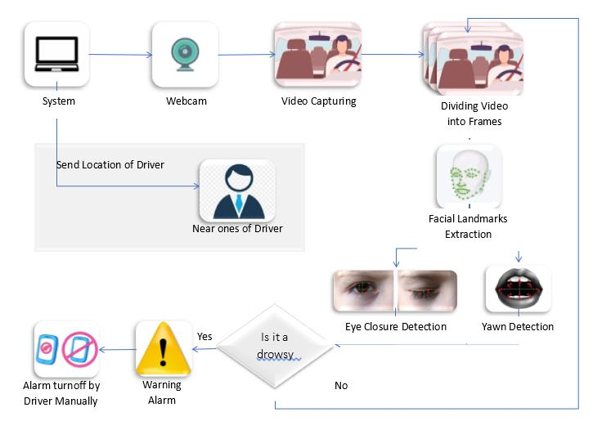

Fig -1: Block diagram of Proposed System

Images of the driver's face have been taken by a webcam. An algorithm has been proposed to determine the degree of drowsiness by estimating the duration of an eyelid blink and yawning so that the driver is warned accordingly. If the eyes are found closed or the mouth is found open for 30 consecutive frames, at that point, the system infers that the driver is sleeping and issues an admonition signal.

The sequence of photographs of a face, as well as the examination of eye movements and blink variations, has all been used to detect exhaustion. Yawning has been included to make the system more precise by determining the movement of the mouth. Once the position of the eyes and mouth has been located, the system can detect fatigue.

1. **Advantages of Proposed System**
2. The location of the driver is sent to the near and dear ones of the driver so that in the case of an accident with the driver, near and dear ones would get to know on time.
3. In addition, the warning signal is disabled manually instead of automatically. This could ensure the driver's activation as until he sets off the alarm, the alarm is not going to off.
4. **LITERATURE SURVEY**

To improve accuracy and boost up the detection of drowsiness, numerous techniques have been introduced. This segment attempts to encapsulate earlier techniques and processes for detection of drowsiness.

## **EEG based Drowsiness Detection for Safe Driving Using Chaotic Features and Statistical Tests, Zahra Mardi, Seyedeh Naghmeh Miri Ashtiani, Mohammad Mikaili [4]**

This primary set of strategy explore data derived from physiological sensors, which includes Electrooculography (EOG), Electrocardiogram (ECG) and Electroencephalogram (EEG) data. EEG indications give records about the behavior of brain. The three central indications to quantify driver’s sleepiness are theta, delta, and alpha indications. Theta and delta indications shoot up when a person sitting in a vehicle is sluggish, while alpha indications rise marginally. According to Mardi et al., this methodology is the most precise method with precision rate of more than 90% [4]. Yet, the foremost drawback of this strategy is its intrusion. For this, several sensors must be placed on the person’s body, which can be inconvenient. At the same time, unobtrusive methods are far less accurate than bio-signals.

## **Steering Wheel Behavior Based Estimation of Fatigue, Jarek Krajewski, David Sommer, UdoTrutschel, Dave Edwards, Martin Golz [5]**

The technique already used depends on driving style and is tremendously relying on automobile features, street surroundings, and driving capability. To calculate driving style, deflection must be estimated from lateral or lane position or steering wheel speed. While driving, it's vital to make micro-modifications to the steering wheel to preserve the automobile in one lane. Krajewski detected drowsiness with 86% accuracy on the basis of interrelationship between little-adjustments and sleepiness [5]. In addition, it is possible to use lane position deviations to discover driving patterns. In this situation, the position of the automobile corresponding to a specified lane is observed, and deflections are examined. Yet, methods dependent on driving examples are profoundly reliant on vehicle attributes, street environment, and driving capabilities. Hence, this methodology is inconsistent.

## **Driver Drowsiness Detection Model Using Convolutional Neural Networks Techniques for Android Application, RatebJabbar, Mohammad Shinoy, Mohamed Kharbeche, Khalifa Al-Khalifa, Moez Krichen, Kamel Barkaoui [6]**

Another approach for detecting a driver's drowsiness is through neural networks. RatebJabbar focuses on the spotting of such little sleep and exhaustion with the usage of neural network-based strategies. The author proposed a system in which accuracy is improved by way of the use of facial features which are spotted via the camera and surpassed to CNN to classify sluggishness. The primary achievement of this system is its potential to offer light-weight alternatives to heavy classification models with above 88% for the class without glasses, above 85% for the class night without glasses [6]. On average, more than 83% of precision is accomplished in all classes. Though, the principle obstacle of this system is its complexity and intensive computation.

## **Real Time Eye Detection and Tracking Method for Driver Assistance System, Sayani Ghosh, T.Nandy, Nilotpal Manna [7]**

The final category includes behavioral or computer vision measures which are reliable in comparison to vehicle-based due to the fact that they focus on the individual instead of the automobile. Moreover, behavioral measures are unobtrusive and more realistic than physiological measures. Here, data is derived by using webcams to discover mild modifications in the facial expressions of the driver. As behavioral measures are unobtrusive in nature, they are turning into the accepted approach to detect sleepiness. In this paper, the author gives details of concurrent eye detection and tracking method that works under variable and practical light situations [7]. It primarily depends on a hardware system for the dynamic-time receiving of a person’s images using an IR illuminator and the software implementation for tracking eyes that could reduce injuries.

1. **METHODOLOGY**

The principle challenge for identifying drowsiness is to determine fatigue by facial expression and to measure it. To do this, the system detects drowsiness in real time by observing the driver’s eyes and mouth. The driver face monitoring system checks the actual condition of the driver based on the processing of the driver's face image. Driver's exhaustion status is identified from eyelids closure, eye blinking, the distance between eyelids, and yawning in this proposed system. Furthermore, if the driver gets tired, the system produces an alarm until the driver becomes alert and recaptures awareness. The stages of the proposed system are described in Fig -2 through a flowchart.

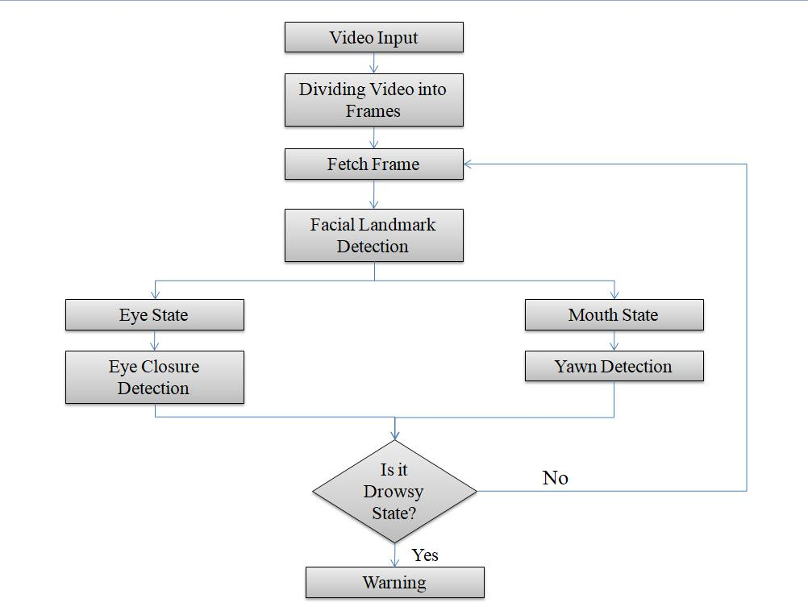

Fig -2: Flowchart of Proposed System

As a first step, the real time video is taken as an input and then the footage is separated up into multiple frames, each of which is then processed further. In second step, the system locates facial landmarks from the frame. And then features are extracted from facial components and landmarks. The proposed system is able to detect the facial features at different angles and also in dim light as shown in Fig -3.

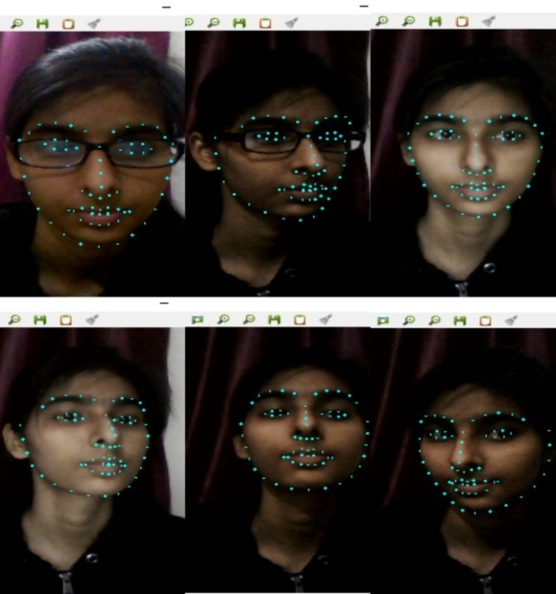

Fig -3: Facial Landmark Detection

After the localization of the driver’s facial features, the next challenge is to find out the state of eyes and mouth. The blinking ratio is then determined. In case of blink detection, 30 consecutive frames are observed and if the eyes are found closed in those frames then the system count it as a blink and after 3 blinks it gives a warning alarm and if the eyes of the driver are found closed for more than 90 frames then also it generates a warning alarm.

Detection of eye state is not a sufficient factor to determine fatigue and drowsiness, yawing detection is also an essential feature for this. In the yawning position, the mouth becomes wider and the geometric features of the mouth change. When the mouth begins to open, the value of the threshold pixel increases compared to the normal state of the mouth, which is yawning.

In case of yawning, 30 consecutive frames are observed and if mouth is found open in those frames then the system count it as a yawn and after 2 yawn it gives a warning alarm. The implementation of blink and yawn detection is shown in Fig -4. If one or both of the two conditions occur (eyes closed and yawing), the system defines it as a state of drowsiness and a warning alarm is turned on and it remains on until the driver would have come in a normal state. If the system does not find the driver in drowsy state then it continues to receive frames and perform further processing.

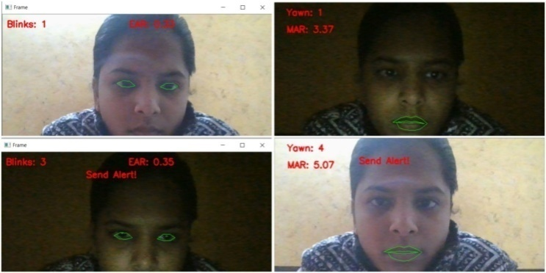

Fig -4: Blink and Yawn Detection

1. **Algorithm**
2. **Analysis of Eye Aspect Ratio-**

Each eye is consists of 6(x,y) coordinates landmarks returned by the dlib predictor function, starting from the left corner of the eye and then work towards the right corner by working around the remainder of the region. There is a connection between the width and the height of these coordinates and this relation is expressed by Eye Aspect Ratio (EAR).

$$Eye Aspect Ratio=\frac{\left|p2-p6\right|+|p3-p5|}{2|p1-p4|}$$

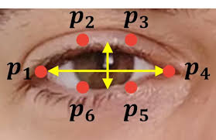

Fig -5: Eye Aspect Ratio Calculation

1. **Analysis of Mouth Aspect Ratio –**

Each eye consists of 20(x,y) coordinates landmarks returned by the dlib predictor function, starting from the left corner of the eye and then work towards the right corner by working around the remainder of the region. There is a connection between the width and the height of these coordinates and this relation is expressed by Mouth Aspect Ratio (MAR).

$$Mouth Aspect Ratio=\frac{\left|C-D\right|+\left|E-F\right|+|G-H|}{3.0}$$

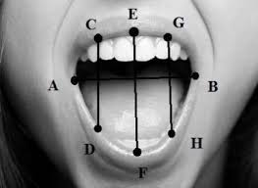

Fig -6 Mouth Aspect Ratio Calculation

1. **COMPARISON OF VARIOUS METHODOLOGIES**

To increase accuracy and speed up the detection of drowsiness, a few methodologies have been proposed. This part endeavors to investigate past techniques for identifying drowsiness and compares past methodologies with the proposed approach.

## **Physiological Method**

This class of methods utilizes information got from the physiological sensors, for example Electrocardiogram (ECG), Electroencephalogram (EEG) and Electrooculography (EOG) information [4]. EEG indicators give data about the operations of the brain. Theta, delta, and alpha signals are the three most important indicators of a driver's drowsiness. When a driver is lethargic, theta and delta signals increase, whereas alpha signals rise marginally. This methodology is the most precise method with precision rate of more than 90% [4]. The biggest con of this method, however, is its intrusion. This necessitates the placement of multiple sensors on the person’s body, which can be cumbersome. Non-intrusive approaches, on the other side, are far less accurate than bio-signals.

## **Subjective Method**

Subjective methods are those which evaluate the degree of drowsiness by the driver's own assessment [8]. The method used here is a questionnaire, and the Karolinska Sleepiness Scale (KSS), a 9-point scale with verbal anchors for each step, is commonly used [9]. Yet, the principle impediment of this technique is that it is unrealistic.

## **Vehicle based Method**

These estimates are derived from a simulated environment by the installation of sensors across different sections of vehicle, for example, the control wheel and the accelerator pedal [5]. The indications sent by the sensor are then analyzed to determine the level of sleepiness. Yet, methods dependent on driving examples are profoundly reliant on vehicle attributes, street environment, and driving capabilities. Hence, this methodology is inconsistent.

## **Behavioral Method**

In this methodology, the behavior of the person driving the vehicle including eye closing, eye blinking, yawning are observed through a webcam and the person driving the vehicle gets alert signal if any of these sleepiness symptoms are detected [7]. And this approach is reliable compared to vehicle-based approach because it centers on the individual as opposed to the vehicle. Also, behavioral measures are unobtrusive and more reliable than physiological measures.

The pros and cons of different types of measures are expressed in Table -1 [10].

Table - 1: Comparison of Different Measures

|  |  |  |  |
| --- | --- | --- | --- |
| Measures | Parameters | Advantages | Disadvantages |
| Physiological measures | Information derived from the physiological sensors | Reliable, Accurate | Intrusive |
| Subjective measures | Questionnaire | Subjective | Unrealistic |
| Vehicle based measures | Steering wheel movement, Standard lane deviation | Non-intrusive | Unreliable |
| Behavioral measures | Eye closure, yawn | Non-intrusive, Ease of use | Lighting condition background |

1. **RESULTS**

The driver can start the system by pressing the START button in the User Interface (UI) which turns on the webcam of the driver’s device and start to monitor his face. The User Interface (UI) of the system looks like as shown in Fig -5.

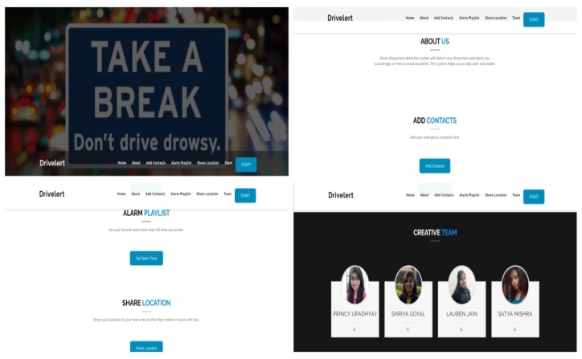

Fig -7: User Interface

Based on the number of blinks and yawn the system generates the alarm signal. The demo of the alarm generation based on 2 eye blinks and 1 yawn is shown in Fig -8.

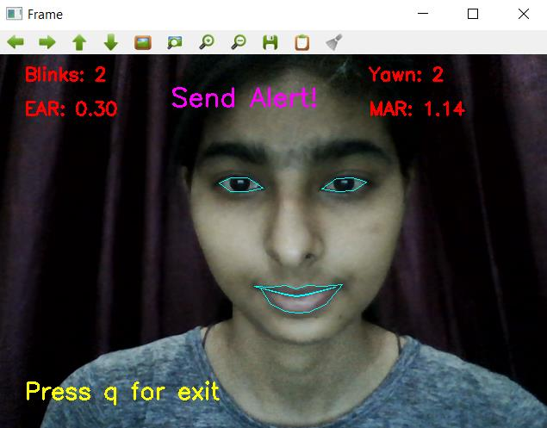

Fig -8: Result of Proposed System

1. **CONCLUSION**

In this paper various methods are reviewed for detecting drowsiness of driver. Subjective, vehicle-based, physical, and behavioral metrics have all been examined [2], with the benefits and drawbacks of each highlighted. The proposed system involves analyzing the facial expression taken by the camera to detect eye blink and yawning. The various motions of the eyes and mouth (such as opening and closing) help detect the level of drowsiness of the driver, which are used to generate warning alarms.

In the proposed system, the driver's drowsiness is detected by analyzing the real-time image taken by the camera using the OpenCV library.

The system involves various steps –

1. The face detection using OpenCV library.
2. Detection of the eye and mouth using dlib library.
3. Detection of the level of drowsiness of driver by calculating Eye Aspect Ratio (EAR) and Mouth Aspect Ratio (MAR).
4. Generation of warning alarm according to EAR and MAR values.

**REFERENCES**

1. Younes Ed-Doughmi1,* , NajlaeIdrissi 1, Youssef Hbali 2: Real-Time System for Driver Fatigue Detection Based on a Recurrent Neuronal Network(2020)
2. Taranpreet Kaur, Sanjay Kumar Singh: Enhance the Driver Drowsiness Detection System Using EDAMAS and Region Prop Techniques(2014)
3. [Muhammad Awais](https://pubmed.ncbi.nlm.nih.gov/?term=Awais+M&cauthor_id=28858220) [1](https://pubmed.ncbi.nlm.nih.gov/28858220/#affiliation-1) [2](https://pubmed.ncbi.nlm.nih.gov/28858220/#affiliation-2), [Nasreen Badruddin](https://pubmed.ncbi.nlm.nih.gov/?term=Badruddin+N&cauthor_id=28858220) [3](https://pubmed.ncbi.nlm.nih.gov/28858220/#affiliation-3) [4](https://pubmed.ncbi.nlm.nih.gov/28858220/#affiliation-4), [Micheal Drieberg](https://pubmed.ncbi.nlm.nih.gov/?term=Drieberg+M&cauthor_id=28858220) [5](https://pubmed.ncbi.nlm.nih.gov/28858220/#affiliation-5): A Hybrid Approach to Detect Driver Drowsiness Utilizing Physiological Signals to Improve System Performance and Wearability(2017)
4. Zahra Mardi, Seyedeh Naghmeh Miri Ashtiani, Mohammad Mikaili: EEG-based Drowsiness Detection for Safe Driving Using Chaotic Features and Statistical Tests(2011)
5. Jarek Krajewski, David Sommer, Udo Trutschel, Dave Edwards, Martin Golz: Steering Wheel Behavior Based Estimation of Fatigue(2009)
6. RatebJabbar, Mohammed Shinoy , Mohamed Kharbeche, Khalifa Al-Khalifa, Moez Krichen, Kamel Barkaoui: Driver Drowsiness Detection Model Using Convolutional Neural Networks Techniques for Android Application(2020)
7. Sayani Ghosh, T. Nandy, Nilotpal Manna: Real Time Eye Detection and Tracking Method for Driver Assistance System(2015)
8. Alina Mashko: Subjective Methods For Assessment Of Driver Drowsiness(2017)
9. [Arun Sahayadhas](https://pubmed.ncbi.nlm.nih.gov/?term=Sahayadhas+A&cauthor_id=23719977)[1](https://pubmed.ncbi.nlm.nih.gov/23719977/#affiliation-1), [Kenneth Sundaraj](https://pubmed.ncbi.nlm.nih.gov/?term=Sundaraj+K&cauthor_id=23719977), [Murugappan Murugappan](https://pubmed.ncbi.nlm.nih.gov/?term=Murugappan+M&cauthor_id=23719977): Drowsiness detection during different times of day using multiple features(2013)

1. [Arun Sahayadhas](https://www.ncbi.nlm.nih.gov/pubmed/?term=Sahayadhas%20A%5BAuthor%5D&cauthor=true&cauthor_uid=23223151),* [Kenneth Sundaraj](https://www.ncbi.nlm.nih.gov/pubmed/?term=Sundaraj%20K%5BAuthor%5D&cauthor=true&cauthor_uid=23223151), [Murugappan Murugappan](https://www.ncbi.nlm.nih.gov/pubmed/?term=Murugappan%20M%5BAuthor%5D&cauthor=true&cauthor_uid=23223151): Detecting Driver Drowsiness Based on Sensors(2012)